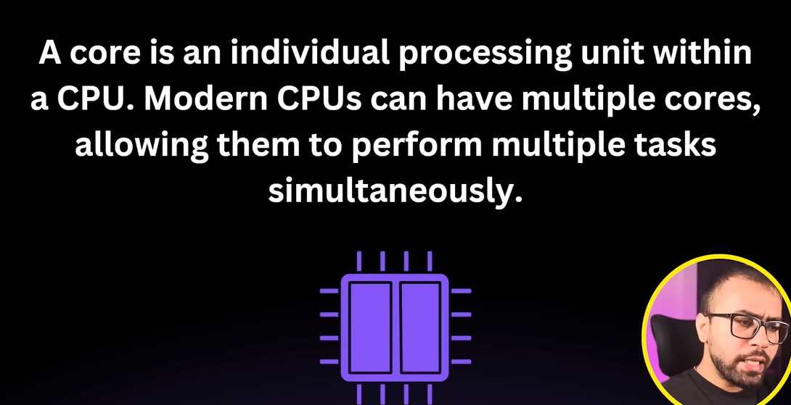

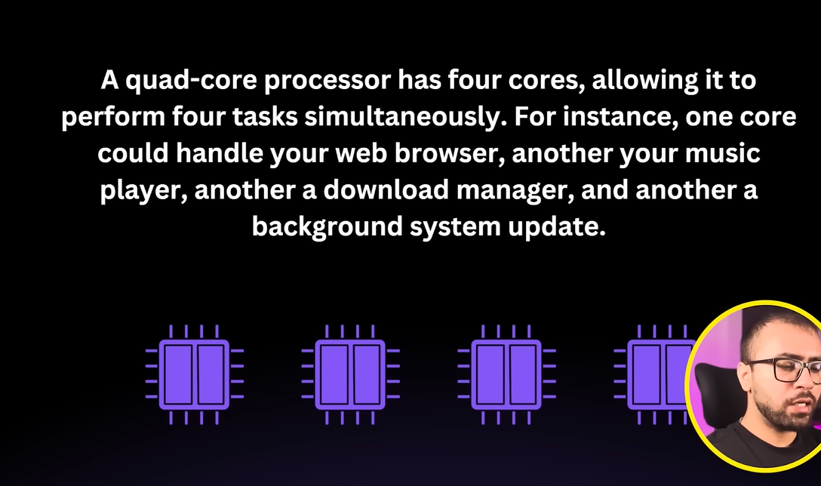

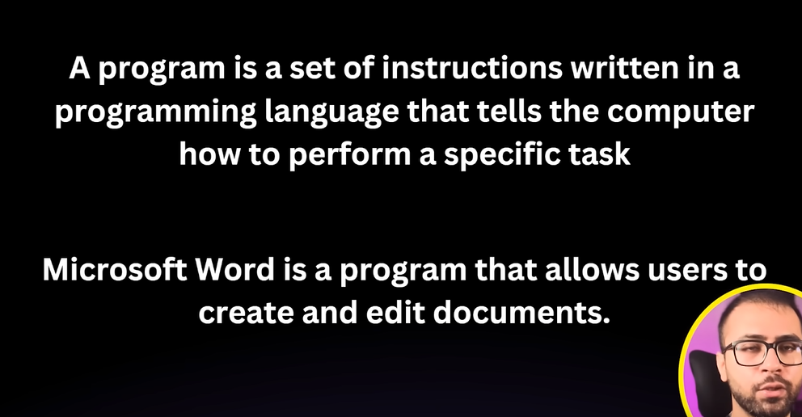

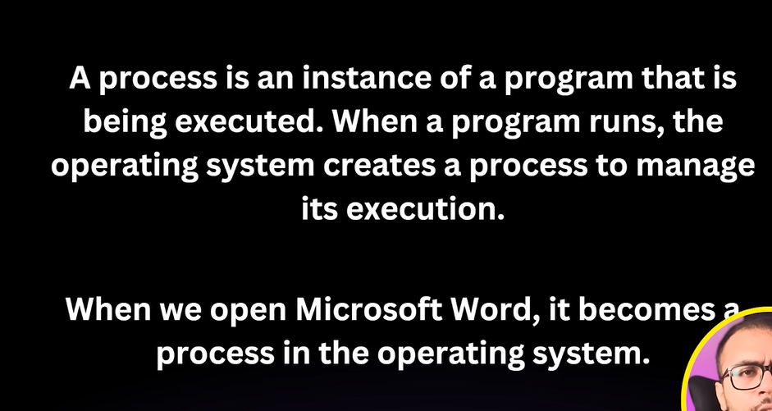

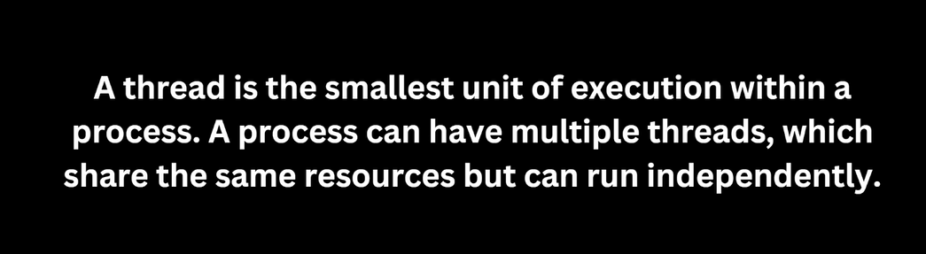

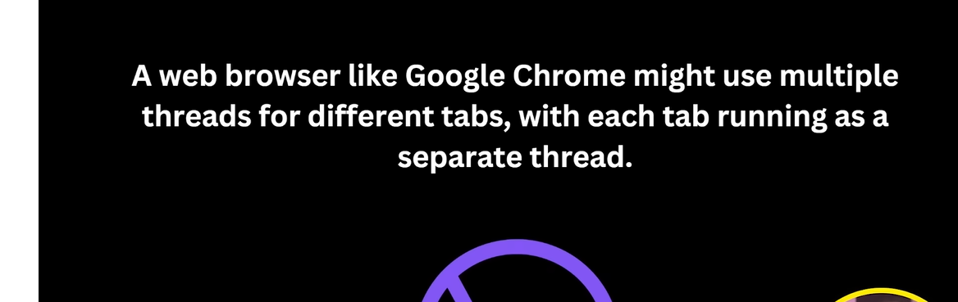

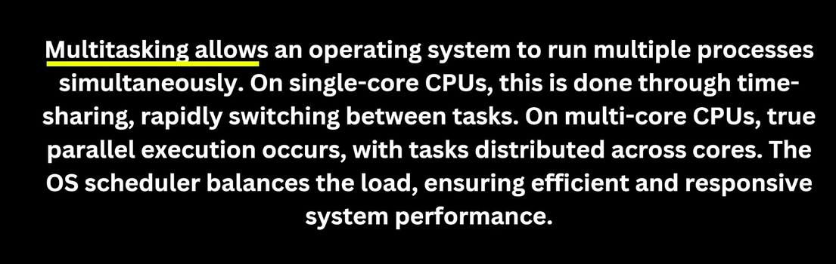

**Operating System** a type of system software. It basically manages all the resources of the computer. An operating system acts as an interface between the software and different parts of the computer or the computer hardware. The operating system is designed in such a way that it can manage the overall resources and operations of the compute

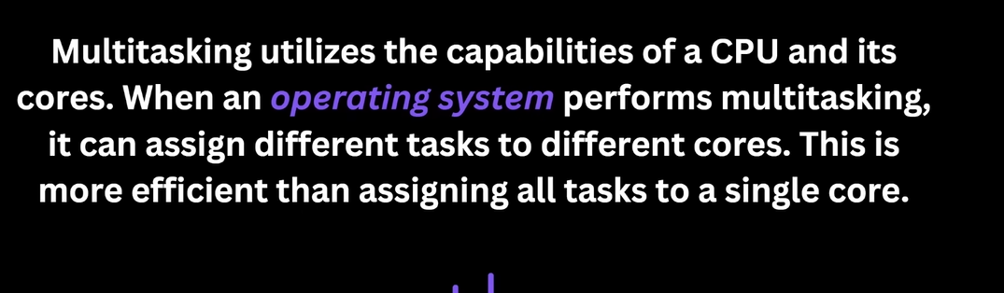

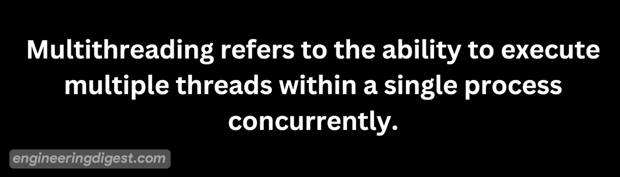

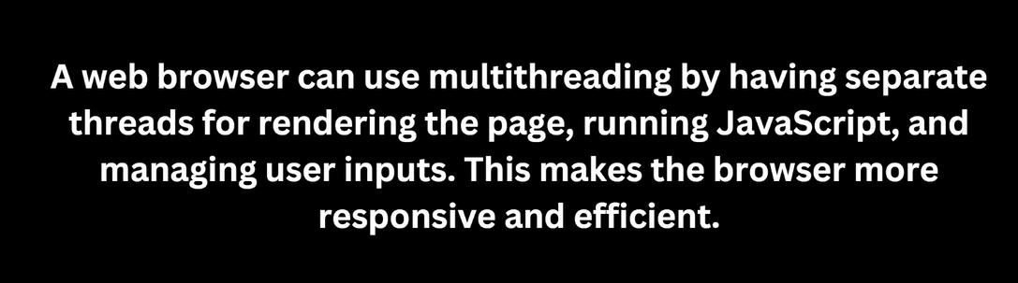

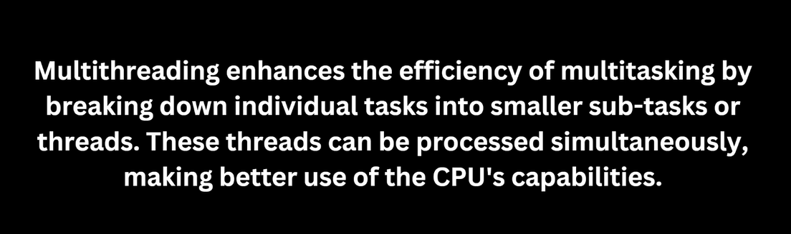

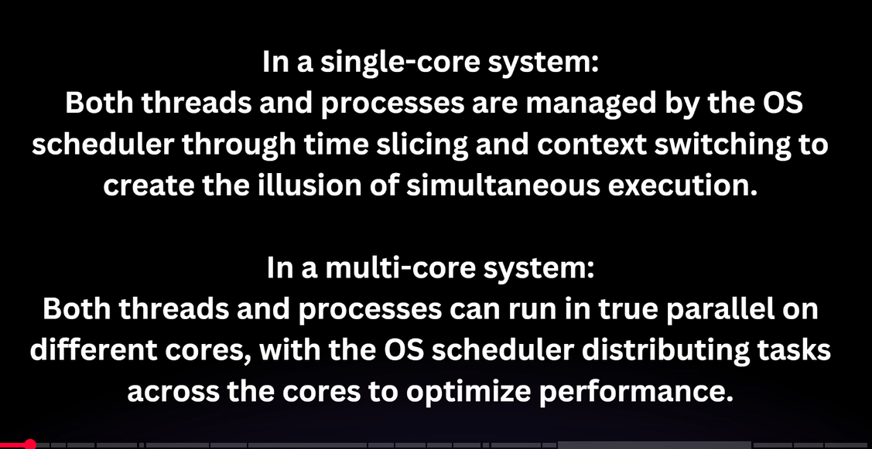

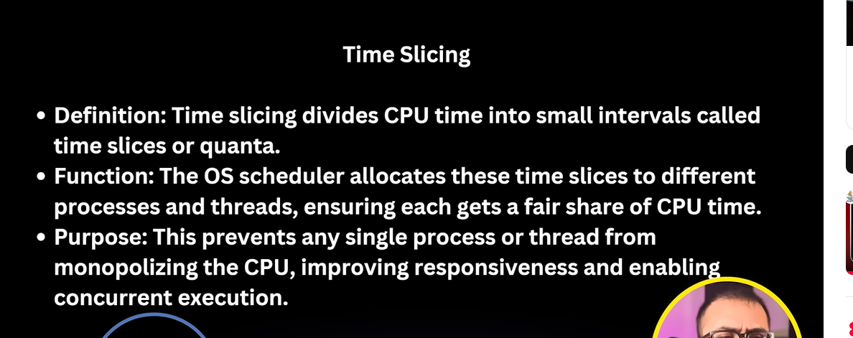

***Time Slicing***

* **Definition:** Time slicing divides CPU time into small intervals called time slices or quanta.
* **Function:** The OS scheduler allocates these time slices to different processes and threads, ensuring each gets a fair share of CPU time.
* **Purpose:** This prevents any single process or thread from monopolizing the CPU, improving responsiveness and enabling concurrent execution.

***Context Switching***

* **Definition:** Context switching is the process of saving the state of a currently running process or thread and loading the state of the next one to be executed.
* **Function:** When a process or thread’s time slice expires, the OS scheduler performs a context switch to move the CPU’s focus to another process or thread.
* **Purpose:** This allows multiple processes and threads to share the CPU, giving the appearance of simultaneous execution on a single-core CPU or improving parallelism on multi-core CPUs.

